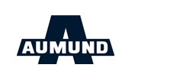

AUMUND Fördertechnik
Home|Sitemap|Imprint|GTC
DE|EN|RU

- About us
- Industries
- Products
- Service
- News
- Careers
- Contact
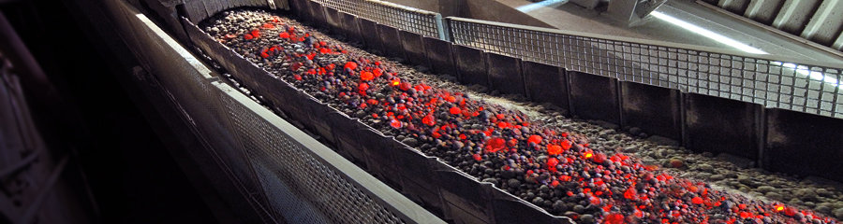
- > Bucket Elevators
- > Pan Conveyors
- > Chain Conveyor
- > Clinker Storage and Discharge
- > Discharge Systems
- > Loading Products
Material, application and local conditions determine the conveyor. Correct design pays off as it is the basis for economic installations. AUMUND has utmost competence in designing, configuration, fabrication, commissioning and maintenance of high-capacity conveyors for continuous production processes. Conveyors from Rheinberg are renowned for their reliability and longevity in the cement, steel or smelting industry, handling of material in power stations, ports or export terminals as well as for extraction and processing of minerals or alternative energy-bearing materials.
- Handling of abrasive materials
- Hot transport up to 1,100° Celsius
- Controlled cool transport
- Vertical conveying to over 170m
- Crusher loading and discharge up to 11,000t/h
- Pressure-shock resistant conveyors
- Conveying under inert gas
- Dosed silo feeding and dosed silo discharge
- Dust-suppressed loading of ships, trains, trucks

